1. **HOUSING PRICES IN METROPOLITAN IN INDIA**

1. INTRODUCTION

Since the inception of the theory and idea of development, the common feature that emerged in different point of time is the developmental gap that emerged in different parts of the world and also among various parts of a country in a particular time period. This disparity in development, like many other indicators, has also been reflected in India. Traditional development theories believed that agriculture, industrialisation, urbanisation, are significant ingredients of growth, and, ultimately important prerequisites for achieving development. Within the economy itself, the status of growth of a state can be judged through its performance in agricultural and industrial production, performance of service sector and urbanisation, and their impact through their contribution in income and employment generation at the national level. Thus, house price behaviour may also reflect some short of developmental status of the households of a country. Keeping in view the above fact of rapid urbanisation and regional disparities, it is not unexpected that it may lead to some sort of differences in regional house prices, where housing and real estate are considered as major sources of physical and financial asset. This also leads to the differences in the dynamics of house price determination. It simply means that there might be shift of house prices in cities from average, in the country, depending upon its economic status. For instance, average house prices in the poorer provinces might be lower than the national average. Similarly, for richer states, the urban house prices, on average might be higher than the national average.

* 1. Overview

The very first type of housing system in India, huts are simple shelters that are not very spacious but are made using natural and easily available materials. Bangalows, Apartment, Penthuses, Eco-friendly. Where housing real estate are considered as major sources of Physical and Financial asset. This also leads to the diffference in the dynamic of house price determination.

1.2 Purpose

* To Analyse is anticipated that the prices of the housing market will growing demand for houses coupled with limited supply.
* To find The Residental real estate market in India is predicted to rise positively in 2023, with a capital value increase of more than 6%.
* Real-estate sector will grow in India by 2025.

2 Problem Definition & Design Thinking

2.1 Empathy Map

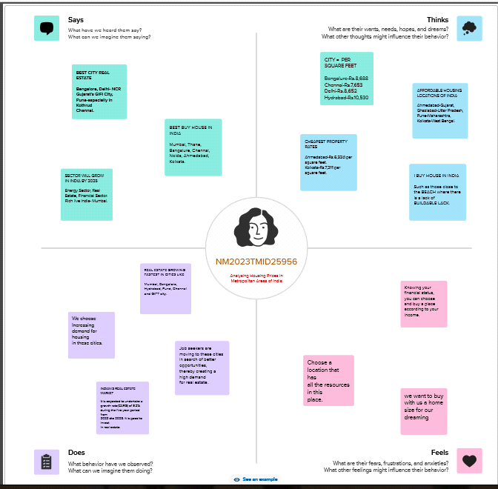

2.2 Ideation & Brainstorming Map

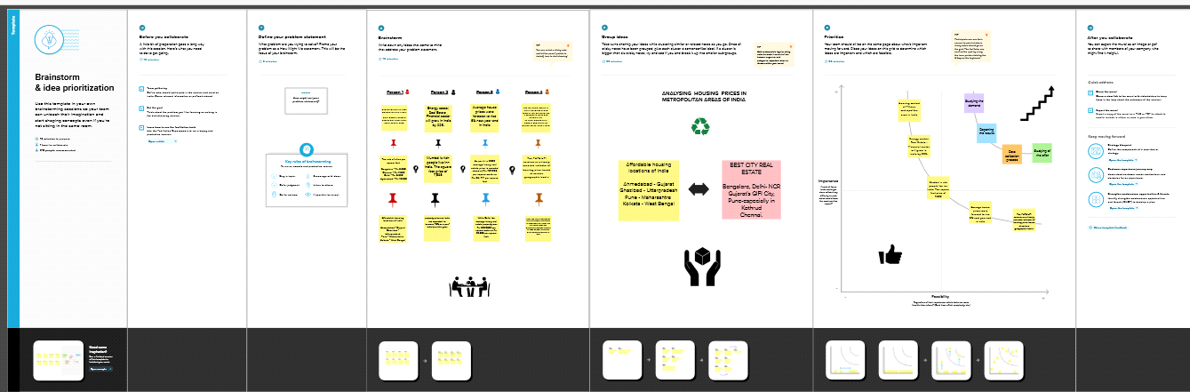

3 RESULT

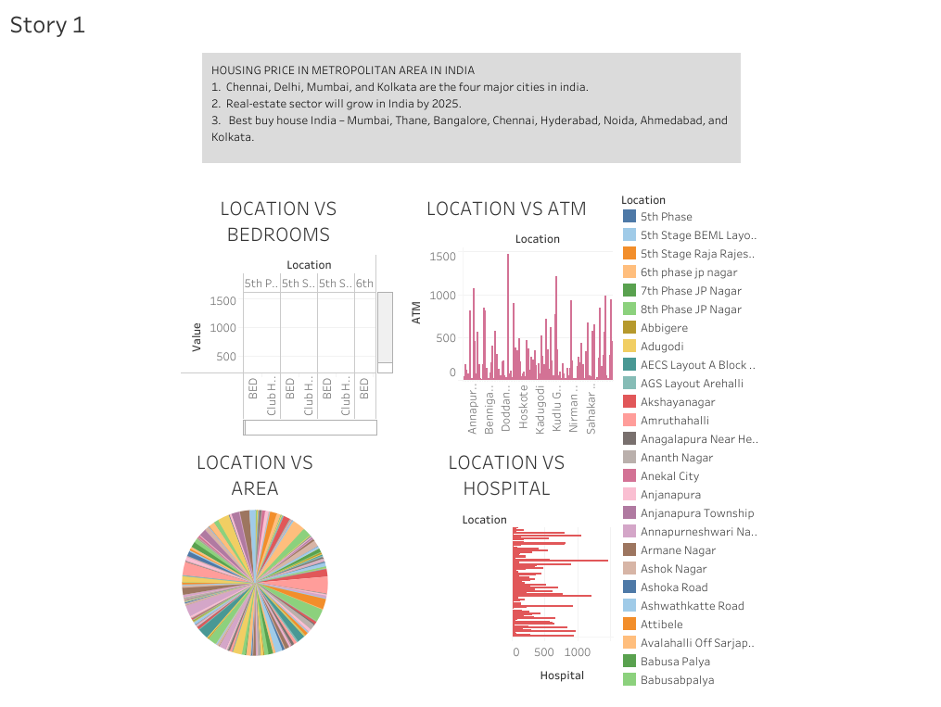

4 ADVANTAGES & DISADVANTAGE

Advantages :

* High-speed public transit system in the form of Metro/Monorail/Metrolite/RRTS/MRTS
* High-speed internet access in the form of Fiber and 5G
* One-day delivery of products including essentials like medicines and groceries
* Facilities of doctor-at-home and ease of access of medical
* Wide varieties of restaurants to order from
* Presence of an International Airport
* Head Offices of institutions, banks, boards, etc. are located
* Modern Infrastructure and better application of technology

Disadvantages :

* High cost of rent and food
* Overpopulation and pollution
* Increased competition and societal callousness

5 APPLICATIONS

* NHB RESIDEX, India's first official housig price index, was an initiative of the National Housing Bank (NHB) undertaken at the behest of the ministry of financie, Government of India.
* House price prediction can help the developer determine the selling price of a house and can help the customer to arrange the right time to purchase a house. There are three factor that influence the price of a house which include physical conditions, concept and location.

6 CONCLUSION

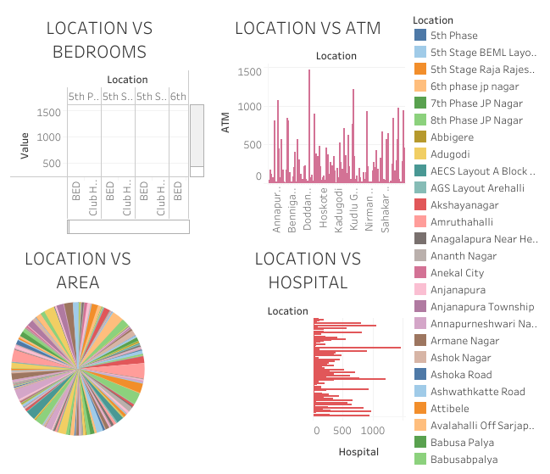

This paper analyzes whether the Law of One Price (LOOP) holds in the housing market of fifteen metropolitan areas in India, namely Delhi, Mumbai, Bengaluru, Kolkata, Chennai, Jaipur, Lucknow, Hyderabad, Pune, Surat, Ahmedabad, Patna, Faridabad, Kochi and Bhopal. We test the existence of LOOP using the Im, Pesaran and Shin (2003) panel unit root test based on quarterly data on residential property prices covering the period of 2007Q1 to 2011Q4 of the Indian housing market. Based on the criterion of price convergence, house prices in the 15 metropolitan cities do not converge to the LOOP. This implies that the housing markets in the different areas operate as segmented independent local markets. Therefore, house prices in one location in India cannot impose a competitive constraint on house prices in other location, and as such a home owner can freely set the price of his house.

7 FUTURE SCOPE

* Real estate market in India at a Glance In 2021, the size of the Indian property market was USD 200 billion. Projected growth by 2023 for the sector is USD 1 trillion. What is more, by 2025, the real este sector is expected to contriburte 13% of the country total GDP.
* The project growth by 2030 for the sector is USD 1 trillion.

8 APPENDIX

TABLUE PUBLIC LINK: <https://public.tableau.com/app/profile/saminathan.c/viz/HOUSINGPRICESINMETROPOLITANAREAOFINDIA/Story1?publish=yeS>

NANMUTHALVAN COURSE LINK:

Saminathan = <https://naanmudhalvan-as.teachable.com/courses/enrolled/2160671>

Santhosh Kumar = <https://naanmudhalvan-as.teachable.com/courses/enrolled/2160671>

AARTHI: <https://naanmudhalvan-as.teachable.com/courses/enrolled/2160671>

ABARNA: https://naanmudhalvan-as.teachable.com/courses/enrolled/2160671

1. Source Cod

e

Attach the code for the solution built.